3.51: Take 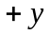 to be downward.
Use the vertical motion to find the time in the air:
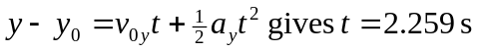
During this time the dart must travel 90 m horizontally, so the horizontal component of its velocity must be
